RED: PLIFNeuronPool_Separable_Pool3d(multiply_factor = 1.).to(device) #ts 21

Entrenamiento: ./results/checkpoints/poolingnet_seg_lif3x3_wall_max1_5_batch1_lr_5_3_super.pth

general_config: "/content/drive/MyDrive/StereoSpike/general_config_Dani.yaml"

# For more descriptions, look at 'config/config.py'.
spikeConversion:
intensity: 128
simulation:
Ts: 1 # Time-discretization in seconds
tSample: 21 # 1 100 10 Number of simulation steps
tStartLoss: 5 # Start computing loss at this time-step
data:
height: 260
width: 346
height_c: 128
width_c: 128
k: 1 #number of event indexes to use
minEvents: 30
start: 5 # some datasets start numbering mask images with an index other than 1
timePerMask: 0.001000000 # 0.001000000 0.1000000 0.010000000
batchsize: 2 #8
hardware:
readerThreads: 4 # 4
gpuDevice: 0
model:
dtype:
testSplit: 0.1
neuron:
type: SRMALPHA
theta: 0.22
tauSr: 2.0
tauRef: 1.0
scaleRef: 2 # relative to theta
tauRho: 1 # relative to theta
scaleRho: 0.20

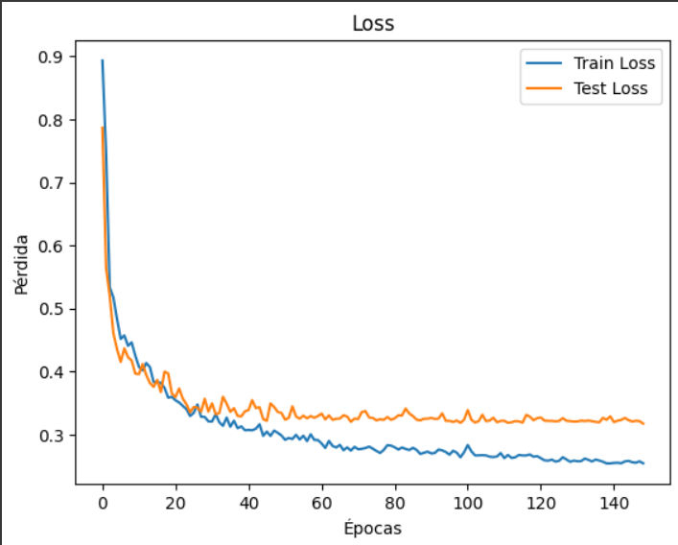
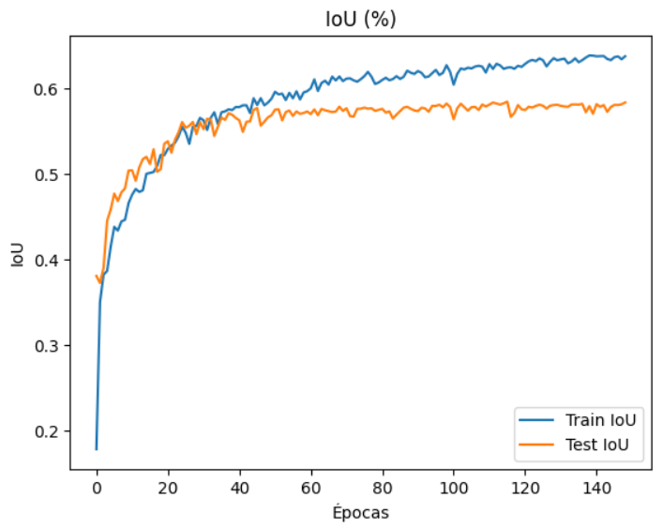

RED: PLIFNeuronPool_Separable_Pool3d

maxBackgroundRatio = 5
Datasets 01 y 02 concatenados table

